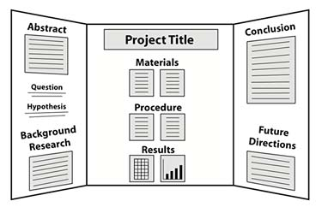

Advice:

* Use large font (you should be able to stand 5 feet from the board and easily read the content) and avoid long paragraphs. Your board gives your judge a snapshot of your project while your report describes in detail.
* Do not put your name on the front of the board or on your research paper. Judges need to be objective.
* Include pictures if applicable (of apparatus or progress of data collection).
* Make sure your graphs are labeled and have titles.
* Neatness matters. Look online for examples of boards. Make a note of those that catch your eye and those that are not all that impressive.
* If you need colored paper for background boarders, glue sticks or markers, I have them in my room for you to use.